**FORM1**

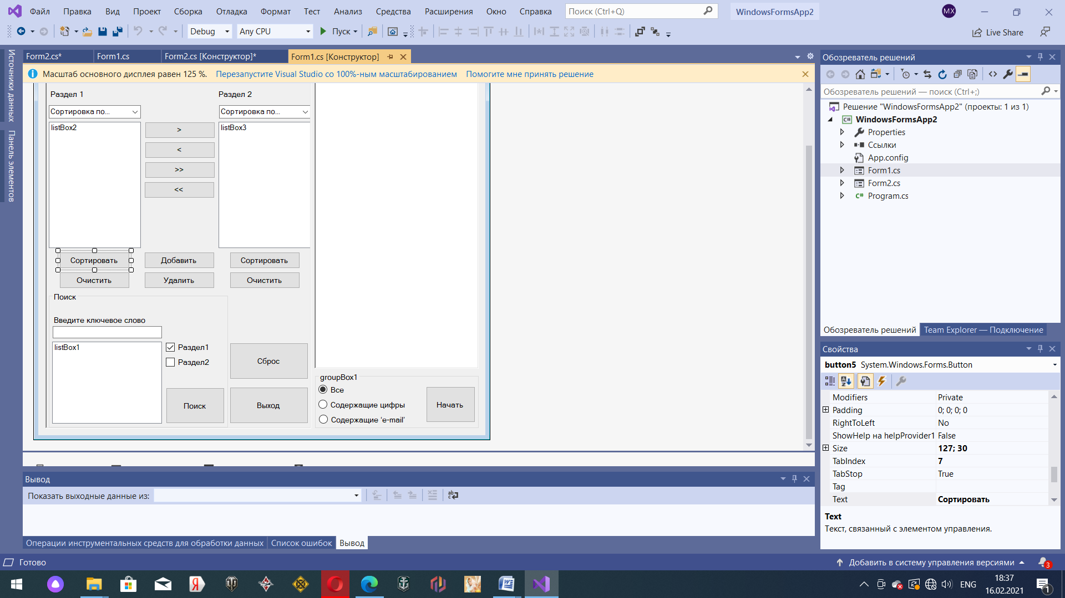

using System;

using System.Collections.Generic;

using System.ComponentModel;

using System.Data;

using System.Drawing;

using System.Linq;

using System.Text;

using System.IO;

using System.Text.RegularExpressions;

using System.Threading.Tasks;

using System.Windows.Forms;

using System.Collections;

namespace WindowsFormsApp2

{

public partial class Form1 : Form

{

public Form1()

{

InitializeComponent();

}

private void Form1_Load(object sender, EventArgs e)

{

}

private void label1_Click(object sender, EventArgs e)

{

}

private void открытьToolStripMenuItem_Click(object sender, EventArgs e)

{

OpenFileDialog OpenDlg = new OpenFileDialog();

if (OpenDlg.ShowDialog() == DialogResult.OK)

{

// Assign the cursor in the Stream to the Form's Cursor property.

//this.Cursor = new Cursor(openFileDialog1.OpenFile());

StreamReader Reader = new StreamReader(OpenDlg.FileName, Encoding.GetEncoding(1251));

richTextBox1.Text = Reader.ReadToEnd();

Reader.Close();

}

OpenDlg.Dispose();

}

private void сохранитьToolStripMenuItem_Click(object sender, EventArgs e)

{

SaveFileDialog SaveDlg = new SaveFileDialog();

if (SaveDlg.ShowDialog() == DialogResult.OK)

{

StreamWriter Writer = new StreamWriter(SaveDlg.FileName);

for (int i = 0; i < listBox3.Items.Count; i++)

{

Writer.WriteLine((string)listBox3.Items[i]);

}

Writer.Close();

}

SaveDlg.Dispose();

}

private void выходToolStripMenuItem_Click(object sender, EventArgs e)

{

Application.Exit();

}

private void toolStripMenuItem1_Click(object sender, EventArgs e)

{

MessageBox.Show("Информация о приложении и разработчике");

}

public void listBox2_SelectedIndexChanged(object sender, EventArgs e)

{

}

public void listBox3_SelectedIndexChanged(object sender, EventArgs e)

{

}

private void button14_Click(object sender, EventArgs e) // Кнопка НАЧАТЬ

{

listBox3.Items.Clear();

listBox2.Items.Clear();

listBox2.BeginUpdate();

string[] Strings = richTextBox1.Text.Split(new char[] { '\n', '\t', ' ' },

StringSplitOptions.RemoveEmptyEntries);

foreach (string s in Strings)

{

string Str = s.Trim();

if (Str == String.Empty) continue;

if (radioButton1.Checked) listBox2.Items.Add(Str);

if (radioButton2.Checked)

{

if (Regex.IsMatch(Str, @"\d")) listBox2.Items.Add(Str);

}

if (radioButton3.Checked)

{

if (Regex.IsMatch(Str, @"\w+@\w+\.\w+")) listBox2.Items.Add(Str);

}

}

listBox2.EndUpdate();

}

private void button12_Click(object sender, EventArgs e) // Кнопка ВЫХОДА

{

Application.Exit();

}

private void button6_Click(object sender, EventArgs e) // Кнопка очистки листа

{

listBox2.Items.Clear();

}

private void button7_Click(object sender, EventArgs e)

{

listBox3.Items.Clear();

}

private void button11_Click(object sender, EventArgs e) // Сброс прогресса

{

listBox1.Items.Clear();

listBox2.Items.Clear();

listBox3.Items.Clear();

richTextBox1.Clear();

textBox1.Clear();

radioButton1.Checked = true;

radioButton2.Checked = false;

radioButton3.Checked = false;

checkBox1.Checked = true;

checkBox2.Checked = false;

}

private void richTextBox1_TextChanged(object sender, EventArgs e)

{

}

private void button13_Click(object sender, EventArgs e)

{

listBox1.Items.Clear();

//string Find = textBox1.Text;

if (checkBox1.Checked)

{

listBox1.Items.Clear();

string Find = textBox1.Text;

foreach (string String in listBox2.Items)

{

if (String.Contains(Find)) listBox1.Items.Add(String);

}

}

if (checkBox2.Checked)

{

listBox1.Items.Clear();

string Find = textBox1.Text;

foreach (string String in listBox3.Items)

{

if (String.Contains(Find)) listBox1.Items.Add(String);

}

}

}

private void button10_Click(object sender, EventArgs e) // Добавить

{

Form2 AddRec = new Form2

{

Owner = this

};

AddRec.ShowDialog();

}

private void button9_Click(object sender, EventArgs e) // ХЗ ЧЕ ЭТ

{

for (int i = listBox2.Items.Count - 1; i >= 0; i--)

{

if (listBox2.GetSelected(i)) listBox2.Items.RemoveAt(i);

}

for (int i = listBox3.Items.Count - 1; i >= 0; i--)

{

if (listBox3.GetSelected(i)) listBox3.Items.RemoveAt(i);

}

}

private void button1_Click(object sender, EventArgs e)

{

listBox3.BeginUpdate();

foreach (object Item in listBox2.SelectedItems)

{

listBox3.Items.Add(Item);

}

listBox3.EndUpdate();

listBox2.Items.RemoveAt(listBox2.SelectedIndex);//удаляет

}

private void button2_Click(object sender, EventArgs e)

{

listBox2.BeginUpdate();

foreach (object Item in listBox3.SelectedItems)

{

listBox2.Items.Add(Item);

}

listBox2.EndUpdate();

listBox3.Items.RemoveAt(listBox3.SelectedIndex);//удаляет

}

private void button3_Click(object sender, EventArgs e)

{

listBox3.Items.AddRange(listBox2.Items);

listBox2.Items.Clear();

}

private void button4_Click(object sender, EventArgs e)

{

listBox2.Items.AddRange(listBox3.Items);

listBox3.Items.Clear();

}

private void ComboBox3_SelectedIndexChanged(object sender, EventArgs e)

{

}

private void button5_Click(object sender, EventArgs e)

{

string selectedState = comboBox2.SelectedItem.ToString();

switch (comboBox2.SelectedIndex)

{

case 0:

//Po alfavitu

listBox2.Sorted = false;

listBox2.Sorted = true;

break;

case 1:

//Po alfavitu v obratnom

for (int i = 0; i < listBox2.Items.Count / 2; i++)

{

listBox2.Sorted = true;

var tmp = listBox2.Items[i];

listBox2.Items[i] = listBox2.Items[listBox2.Items.Count - i - 1];

listBox2.Items[listBox2.Items.Count - i - 1] = tmp;

}

break;

case 2:

//Sortirovka po vozrast. dliny

ArrayList items_1 = new ArrayList(listBox2.Items);

listBox2.Sorted = false;

items_1.Sort(new ByStingLengthComparer1());

listBox2.Items.Clear();

listBox2.Items.AddRange(items_1.ToArray());

break;

case 3:

//Sortirovka po ubyvan. dliny

ArrayList items_2 = new ArrayList(listBox2.Items);

listBox2.Sorted = false;

items_2.Sort(new ByStingLengthComparer2());

listBox2.Items.Clear();

listBox2.Items.AddRange(items_2.ToArray());

break;

}

}

private void comboBox2_SelectedIndexChanged(object sender, EventArgs e)

{

}

private void button8_Click(object sender, EventArgs e)

{

string selectedState = comboBox3.SelectedItem.ToString();

switch (comboBox3.SelectedIndex)

{

case 0:

listBox3.Sorted = false;

listBox3.Sorted = true;

break;

case 1:

for (int i = 0; i < listBox3.Items.Count / 2; i++)

{

listBox3.Sorted = true;

var tmp = listBox3.Items[i];

listBox3.Items[i] = listBox3.Items[listBox3.Items.Count - i - 1];

listBox3.Items[listBox3.Items.Count - i - 1] = tmp;

}

break;

case 2:

//Sortirovka po vozrast. dliny

ArrayList items_1 = new ArrayList(listBox3.Items);

listBox3.Sorted = false;

listBox3.Items.Clear();

items_1.Sort(new ByStingLengthComparer1());

listBox3.Items.AddRange(items_1.ToArray());

break;

case 3:

//Sortirovka po ubyvan. dliny

ArrayList items_2 = new ArrayList(listBox3.Items);

listBox3.Sorted = false;

listBox3.Items.Clear();

items_2.Sort(new ByStingLengthComparer2());

listBox3.Items.AddRange(items_2.ToArray());

break;

}

}

public class ByStingLengthComparer1 : IComparer

{

public int Compare(object x, object y)

{

int xStringLength = x.ToString().Length;

int yStringLength = y.ToString().Length;

return xStringLength.CompareTo(yStringLength);

}

}

public class ByStingLengthComparer2 : IComparer

{

public int Compare(object x, object y)

{

int xStringLength = x.ToString().Length;

int yStringLength = y.ToString().Length;

return yStringLength.CompareTo(xStringLength);

}

}

private void checkBox1_CheckedChanged(object sender, EventArgs e)

{

}

}

}

**FORM2**

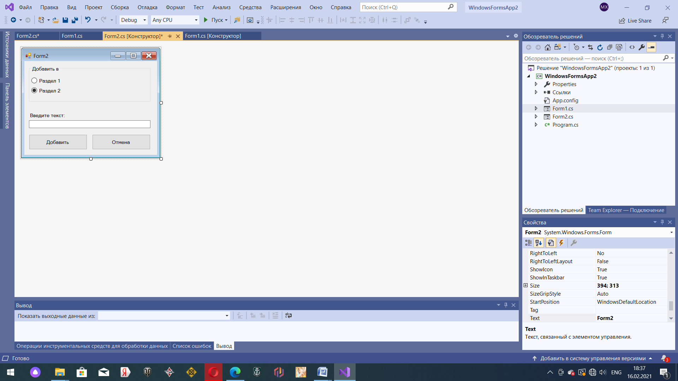

using System;

using System.Collections.Generic;

using System.ComponentModel;

using System.Data;

using System.Drawing;

using System.Linq;

using System.Text;

using System.Threading.Tasks;

using System.Windows.Forms;

namespace WindowsFormsApp2

{

public partial class Form2 : Form

{

public Form2()

{

InitializeComponent();

}

private void label1_Click(object sender, EventArgs e)

{

}

private void button1_Click(object sender, EventArgs e)

{

Form1 Main = this.Owner as Form1;

if (textBox1.Text != "")

{

if (this.radioButton1.Checked == true)

Main.listBox2.Items.Add(this.textBox1.Text);

else Main.listBox3.Items.Add(this.textBox1.Text);

this.Close();

}

}

private void button2_Click(object sender, EventArgs e)

{

this.Close();

}

private void Form2_Load(object sender, EventArgs e)

{

}

}

}